| **Test Name** | | | Login | | | |
| --- | --- | --- | --- | --- | --- | --- |
| **Use Case Tested:** | | | Login-Check Editable Fields | | | |
| **Test Description:** | | | Verify that login form has input fields username and password fields and that these are editable | | | |
| **Pre-conditions** | | | Login screen must be open | | | |
| **Post-conditions** | | | That all input fields are filled | | | |
| **Notes:** | |  | | | | |
| **Result (Pass/Fail/Warning/Incomplete)** | | **Pass** | | | | |
|  | **TEST STEP** | | | **EXPECTED TEST RESULTS** | P | F |
|  | Does Login form have username input field | | | That input field exists | P |  |
|  | Does Login form have password input field | | | That input field exists | P |  |
|  | Type information into editable fields | | | That the user can type required details into input fields | P |  |
|  | Is password viewable | | | Password should show as asterisk’s | P |  |

|  |  |  |  |  |  |
| --- | --- | --- | --- | --- | --- |
| **Test Data Table** | | | | | |
|  | **1** | **2** | **3** | **4** | **5** |
| Username | Test123 |  |  |  |  |
| Password | Test1234 |  |  |  |  |

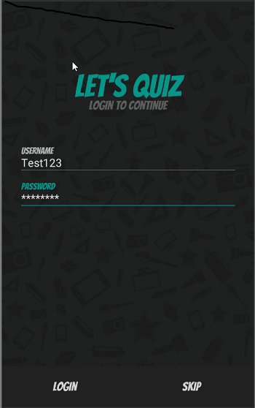

Input fields editable and password shown as asterisk’s

| **Test Name** | | | Login account | | | |
| --- | --- | --- | --- | --- | --- | --- |
| **Use Case Tested:** | | | Login-Blank Username | | | |
| **Test Description:** | | | Verify that entering blank spaces on username field produces error message | | | |
| **Pre-conditions** | | | Login screen must be open | | | |
| **Post-conditions** | | | Error message should be displayed | | | |
| **Notes:** | |  | | | | |
| **Result (Pass/Fail/Warning/Incomplete)** | | **Pass** | | | | |
|  | **TEST STEP** | | | **EXPECTED TEST RESULTS** | **P** | **F** |
| 1 | Leave username blank and hit register | | | Error message username cannot be empty is displayed | **p** |  |

|  |  |  |  |  |  |
| --- | --- | --- | --- | --- | --- |
| **Test Data Table** | | | | | |
|  | **1** | **2** | **3** | **4** | **5** |
| Username blank | empty |  |  |  |  |
| Password | Test1234 |  |  |  |  |

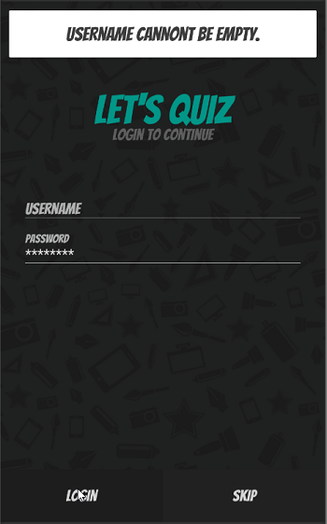

Username empty and error message displayed

| **Test Name** | | | Login | | | |
| --- | --- | --- | --- | --- | --- | --- |
| **Use Case Tested:** | | | Login-Blank password | | | |
| **Test Description:** | | | Verify that entering blank spaces on password field produces error message | | | |
| **Pre-conditions** | | | Login screen must be open | | | |
| **Post-conditions** | | | Error message should be displayed | | | |
| **Notes:** | |  | | | | |
| **Result (Pass/Fail/Warning/Incomplete)** | | **Pass** | | | | |
|  | **TEST STEP** | | | **EXPECTED TEST RESULTS** | **P** | **F** |
| 1 | Leave password blank and hit register | | | Error message password cannot be empty is displayed | **p** |  |

|  |  |  |  |  |  |
| --- | --- | --- | --- | --- | --- |
| **Test Data Table** | | | | | |
|  | **1** | **2** | **3** | **4** | **5** |
| Username | Test123 |  |  |  |  |
| Password | Empty |  |  |  |  |

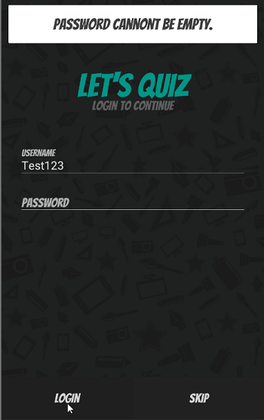

Password empty and error message displayed

| **Test Name** | | | Login account | | | |
| --- | --- | --- | --- | --- | --- | --- |
| **Use Case Tested:** | | | Login- Submittal | | | |
| **Test Description:** | | | Verify that clicking on login button after entering all the mandatory fields, submits the data to the server | | | |
| **Pre-conditions** | | | Login screen must be open  Internet connection needed | | | |
| **Post-conditions** | | | User will be logged in | | | |
| **Notes:** | |  | | | | |
| **Result (Pass/Fail/Warning/Incomplete)** | | **Pass** | | | | |
|  | **TEST STEP** | | | **EXPECTED TEST RESULTS** | **P** | **F** |
| 1 | Enter username | | | Username will be filled in | **P** |  |
| 3 | Enter password | | | Password will be filled in | **P** |  |
| 5 | Hit Login button | | | Details should be sent to server and user is logged in with welcome message and them new game page displayed | **P** |  |

|  |  |  |  |  |  |
| --- | --- | --- | --- | --- | --- |
| **Test Data Table** | | | | | |
|  | **1** | **2** | **3** | **4** | **5** |
| Username | tester1 | tester2 |  |  |  |
| Password | tester1 | tester2 |  |  |  |

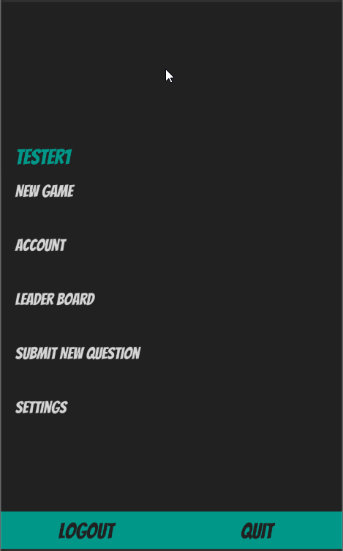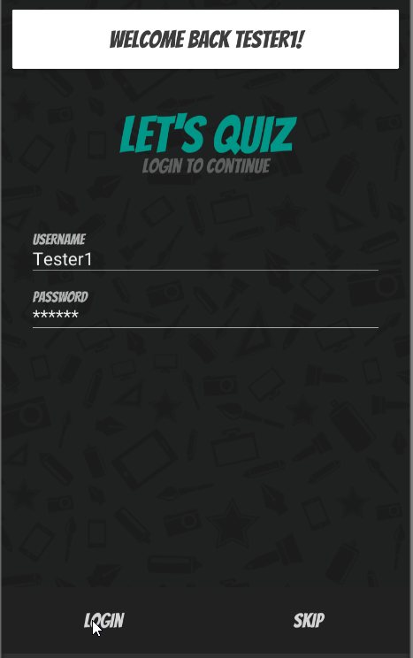

Logged in with welcome message New game page opened

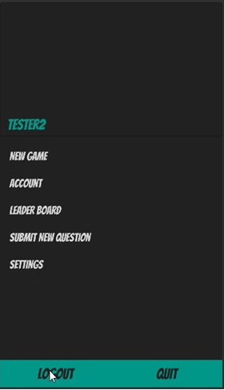

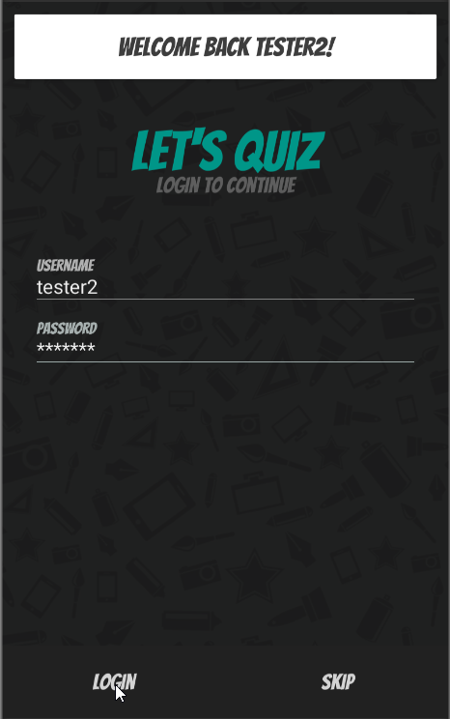

Logged in with welcome message New game page opened

| **Test Name** | | | Login | | | |
| --- | --- | --- | --- | --- | --- | --- |
| **Use Case Tested:** | | | Login-Skip Login | | | |
| **Test Description:** | | | Verify that pressing skip button works to advance forward or go back to login | | | |
| **Pre-conditions** | | | Login screen must be open | | | |
| **Post-conditions** | | | Warning should be displayed allowing user to either continue as guest or exit back to register page | | | |
| **Notes:** | | **Name should have changed to guest all options displayed**  **Redid test name now changes** | | | | |
| **Result (Pass/Fail/Warning/Incomplete)** | | **Failed test round 1**  **Pass test round 2** | | | | |
|  | **TEST STEP** | | | **EXPECTED TEST RESULTS** | **P** | **F** |
| 1 | Press skip button | | | Should display warning that informs user logging in as a guest limits what you can do with a confirmation button or cancel button | **P** |  |
| 2 | Press confirmation button(login) on warning panel | | | Should advance to game choose panel | **P** |  |
| 3 | User name should change when on new game screen | | | Should say Guest and limited options displayed |  | **F** |
| 4 | Press return button(cancel) on warning panel | | | Should return to login panel | **P** |  |
| 1 | Press skip button | | | Should display warning that informs user logging in as a guest limits what you can do with a confirmation button or cancel button | **P** |  |
| 2 | Press confirmation button(login) on warning panel | | | Should advance to game choose panel | **P** |  |
| 3 | User name should change when on new game screen | | | Should say Guest and limited options displayed | **P** |  |
| 4 | Press return button(cancel) on warning panel | | | Should return to login panel | **p** |  |

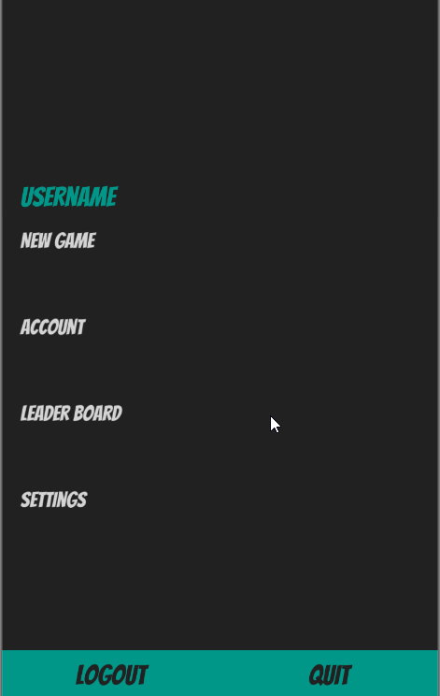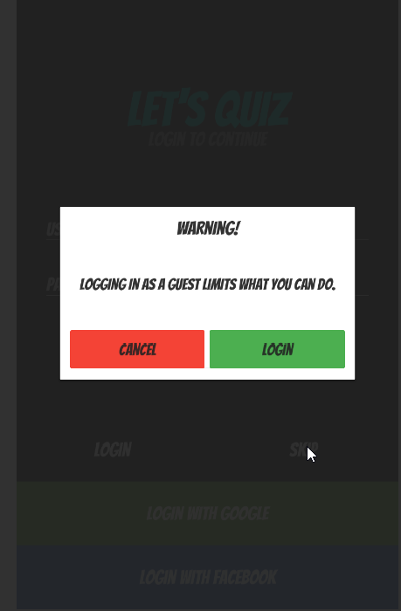

Warning message shown when skip pressed Login button logged in a guest but name did not change nor limit options

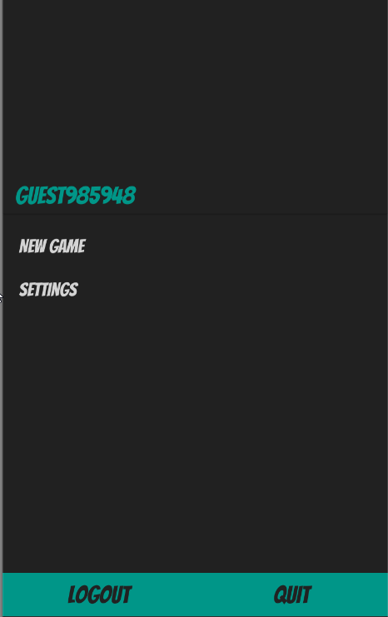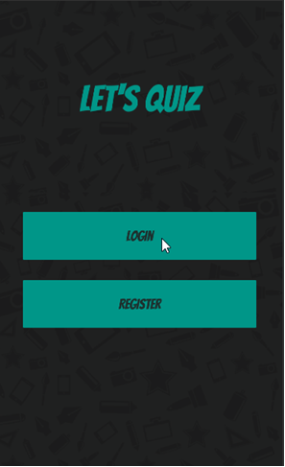

Cancel button returned to login screen Logged in as guest

| **Test Name** | | | Login | | | |
| --- | --- | --- | --- | --- | --- | --- |
| **Use Case Tested:** | | | Log out | | | |
| **Test Description:** | | | Verify that pressing logout logs the user out | | | |
| **Pre-conditions** | | | Menu screen must be open | | | |
| **Post-conditions** | | | User should be logged out | | | |
| **Notes:** | |  | | | | |
| **Result (Pass/Fail/Warning/Incomplete)** | | **Pass** | | | | |
|  | **TEST STEP** | | | **EXPECTED TEST RESULTS** | **P** | **F** |
| 1 | Press logout button | | | Should display a popup box asking if the user is sure they want to logout | **P** |  |
| 2 | Press return button(cancel) on popup | | | Should return to Menu screen | **P** |  |
| 3 | Press confirmation button(log out) on popup | | | Should log player out and take them to the login screen | **P** |  |

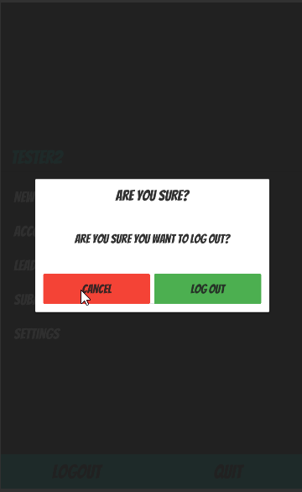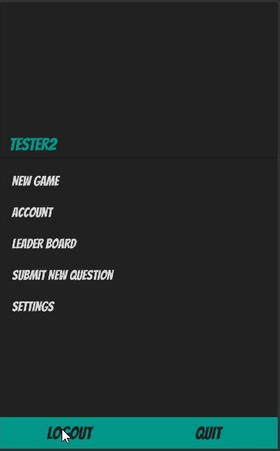

Pressing logout Press cancel

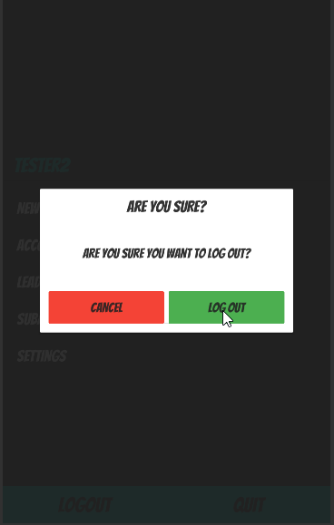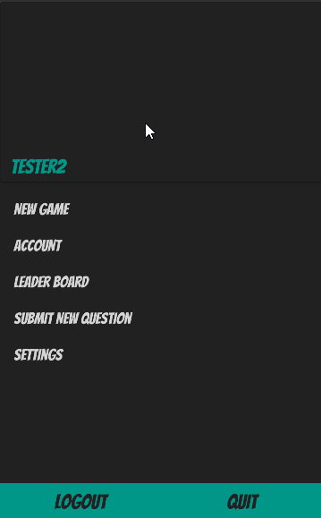

Cancels and returns to menu screen player still logged in Pressed logout

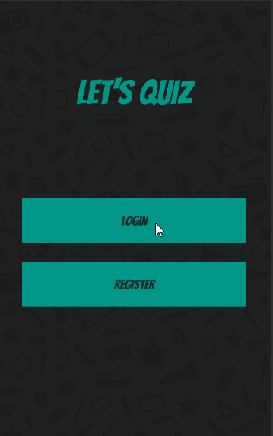

Logs user out and returns to Login register screen

| **Test Name** | | | Login | | | |
| --- | --- | --- | --- | --- | --- | --- |
| **Use Case Tested:** | | | Login-when user opens app and is already logged in | | | |
| **Test Description:** | | | Verify that application goes straight to main menu with welcome back message displayed on splash screen | | | |
| **Pre-conditions** | | | Splash screen must be open  User must be signed in | | | |
| **Post-conditions** | | | That the main menu is opened from splash screen page | | | |
| **Notes:** | |  | | | | |
| **Result (Pass/Fail/Warning/Incomplete)** | | **Pass** | | | | |
|  | **TEST STEP** | | | **EXPECTED TEST RESULTS** | **P** | **F** |
| 1 | User opens game | | | Should skip register login and display main menu with welcome back message displayed on splash screen | **P** |  |

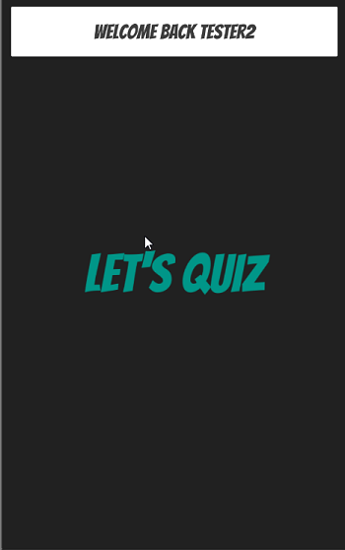

Splash screen with welcome back message Goes straight to Main Menu